WARM UP



|  |  |
| --- | --- |
| **Years after 1999** | **Stores** |
|  |  |
|  |  |
|  |  |
|  |  |
|  |  |

Nadia owns a chain of fast food restaurants that operated 200 stores in 1999. If the rate of increase is 8% annually, how many stores does the restaurant operate in 2007?

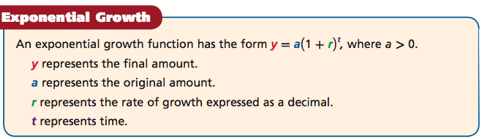

|  |  |
| --- | --- |
| **Example:** Exponential Growth  The original value of a painting is $1400, and the value increases by 9% each year. Write an exponential growth function to model this situation. Then find the value of the painting in 25 years. | **You Try**  A sculpture is increasing in value at a rate of 8% per year, and its value in 2000 was $1200. Write an exponential growth function to model this situation. Then find the sculpture’s value in 2006**.** |

|  |  |
| --- | --- |
| **Hours** | **Percent Left** |
|  |  |
|  |  |
|  |  |
|  |  |
|  |  |

Suppose a radioactive substance decays at a rate of 3.5% per hour. What percent of the substance is left after 6 hours?

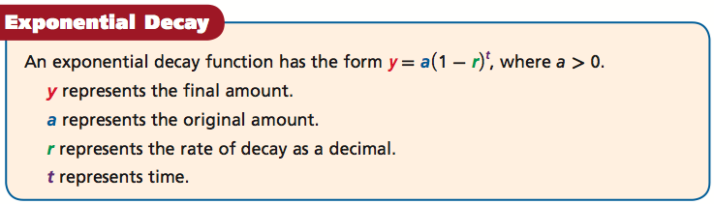

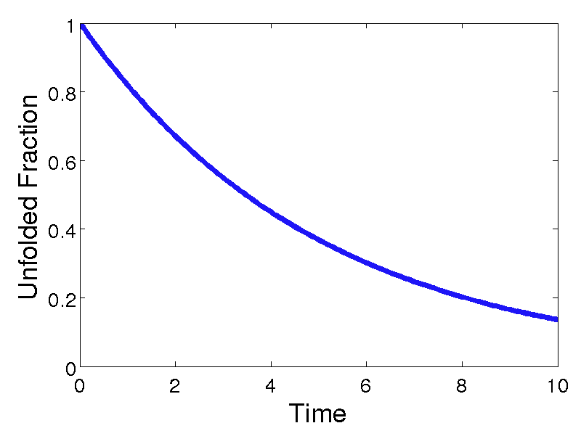

|  |
| --- |
| Notice an important difference between exponential growth and exponential decay functions.  For growth, the value inside the parentheses will be _______________ than 1 because r is added to 1.  For decay, the value inside the parentheses will be ___________ than 1 because r is subtracted from 1. |

|  |  |
| --- | --- |
| **Example 2:** Exponential Decay  The population of a town is decreasing at a rate of 1% per year. In 2000 there were 1300 people. Write an exponential decay function to model this situation. Then find the population in 2008. | **You Try**  The fish population in a local stream is decreasing at a rate of 3% per year. The original population was 48,000. Write an exponential decay function to model this situation. Then find the population after 7 years. |

**Exit Ticket!**

1. The number of employees at a certain company is 1440 and is increasing at a rate of 1.5% per year. Find the number of employees in the company after 9 years.
2. The deer population of a game preserve is decreasing by 2% per year. The original population was 1850. Find the population after 4 years.

**Algebra – U10L2: Analyzing Growth and Decay Problems** Name:_______________________________

**Exit Ticket!**

1. The number of employees at a certain company is 1440 and is increasing at a rate of 1.5% per year. Find the number of employees in the company after 9 years.
2. The deer population of a game preserve is decreasing by 2% per year. The original population was 1850. Find the population after 4 years.